JobsEQ Logo

Industry Spotlight



Total - All Industries

Okaloosa / Walton

cea_image_logo

cea_image_nologo



[Spotlight Summary 3](#_Toc95218123)

[Industry Snapshot 4](#_Toc95218124)

[Staffing Pattern 5](#_Toc95218125)

[Geographic Distribution 6](#_Toc95218126)

[Drivers of Employment Growth 7](#_Toc95218127)

[Employment Distribution by Type 8](#_Toc95218128)

[Establishments 9](#_Toc95218129)

[GDP & Productivity 10](#_Toc95218130)

[Postsecondary Programs Linked to Total - All Industries 11](#_Toc95218131)

[Okaloosa / Walton Regional Map 12](#_Toc95218132)

[Region Definition 13](#_Toc95218133)

[Data Notes 14](#_Toc95218134)

[FAQ 14](#_Toc95218135)

# Spotlight Summary

Total - All Industries  
Okaloosa / Walton – 2021Q2

|  |  |  |  |  |
| --- | --- | --- | --- | --- |
| Employment  cea_image_emplChart  124,812  Regional employment / **151,253,223** in the nation | |  | Wages  cea_image_wageChart  $50,494  Avg Wages per Worker / **$64,141** in the nation | |
| 1.8%🡹  Avg Ann % Change Last 10 Years / **+0.8%** in the U.S.  cea_image_changeEmpl | 100.0%  % of Total Employment / **100.0%** in the U.S.  cea_image_pctEmpl |  | 3.2%🡹  Avg Ann % Change Last 10 Years / **+3.3%** in the U.S.  cea_image_changeWage |  |

Top Occupation Groups

cea_image_staffPatternChart

Top Industries

Avg Ann % Change in Employment, Last 10 Years

|  |  |  |
| --- | --- | --- |
| 2.7 % 🡹  cea_image_topIndustryChart_0  Accommodation and Food Services | 1.5 % 🡹  cea_image_topIndustryChart_1  Retail Trade | 1.4 % 🡹  cea_image_topIndustryChart_2  Public Administration |

# Industry Snapshot

|  |  |  |
| --- | --- | --- |
| Employment  cea_image_emplChart |  | Wages  cea_image_wageChart |

| **2-Digit Industry** | **Empl** | **Avg Ann Wages** | **LQ** | **5yr History** | **Annual Demand** | **Forecast Ann Growth** |
| --- | --- | --- | --- | --- | --- | --- |
| Accommodation and Food Services | 20,308 | $28,123 | 2.14 |  | 3,680 | 1.9% |
| Retail Trade | 17,685 | $34,953 | 1.35 |  | 2,546 | 1.0% |
| Public Administration | 12,860 | $69,182 | 2.09 |  | 1,295 | 0.9% |
| Professional, Scientific, and Technical Services | 12,292 | $85,824 | 1.38 |  | 1,270 | 1.7% |
| Health Care and Social Assistance | 12,265 | $51,696 | 0.66 |  | 1,417 | 2.1% |
| Construction | 8,506 | $46,292 | 1.15 |  | 978 | 1.6% |
| Other Services (except Public Administration) | 7,194 | $35,972 | 1.33 |  | 936 | 1.6% |
| Administrative and Support and Waste Management and Remediation Services | 6,925 | $38,529 | 0.87 |  | 922 | 1.7% |
| Educational Services | 6,234 | $48,205 | 0.62 |  | 688 | 1.7% |
| Real Estate and Rental and Leasing | 4,551 | $46,947 | 2.10 |  | 524 | 1.4% |
| Remaining Component Industries | 15,990 | $64,872 | 0.50 |  | 1,913 | 1.5% |
| **Total - All Industries** | **124,812** | **$50,494** | **1.00** |  | **15,559** | **1.5%** |

|  |  |  |
| --- | --- | --- |
|  |  | Employment is one of the broadest and most timely measures of a region’s economy. Fluctuations in the number of jobs shed light on the health of an industry. A growing employment base creates more opportunities for regional residents and helps a region grow its population. |
|  |  | Since wages and salaries generally compose the majority of a household’s income, the annual average wages of a region affect its average household income, housing market, quality of life, and other socioeconomic indicators. |

# Staffing Pattern

cea_image_staffPatternChart

| **6-digit Occupation** | **Empl** | **Avg Ann Wages** | **Annual Demand** |
| --- | --- | --- | --- |
| Retail Salespersons | 5,026 | $29,100 | 846 |
| Waiters and Waitresses | 4,237 | $27,300 | 932 |
| Fast Food and Counter Workers | 3,938 | $22,900 | 867 |
| Cashiers | 3,712 | $24,100 | 733 |
| Office Clerks, General | 2,459 | $34,000 | 317 |
| Cooks, Restaurant | 2,438 | $30,200 | 468 |
| Customer Service Representatives | 2,209 | $33,000 | 323 |
| General and Operations Managers | 1,976 | $87,600 | 216 |
| Project Management Specialists and Business Operations Specialists, All Other | 1,889 | $80,300 | 212 |
| Stockers and Order Fillers | 1,879 | $29,500 | 287 |
| Remaining Component Occupations | 95,044 | $56,800 | 12,208 |
| **Total** | **124,805** |  |  |

|  |  |  |
| --- | --- | --- |
|  |  | The mix of occupations points to the ability of a region to support an industry and its flexibility to adapt to future demand. Industry wages are a component of the cost of labor for regional employers. |
|  |  |  |

# Geographic Distribution

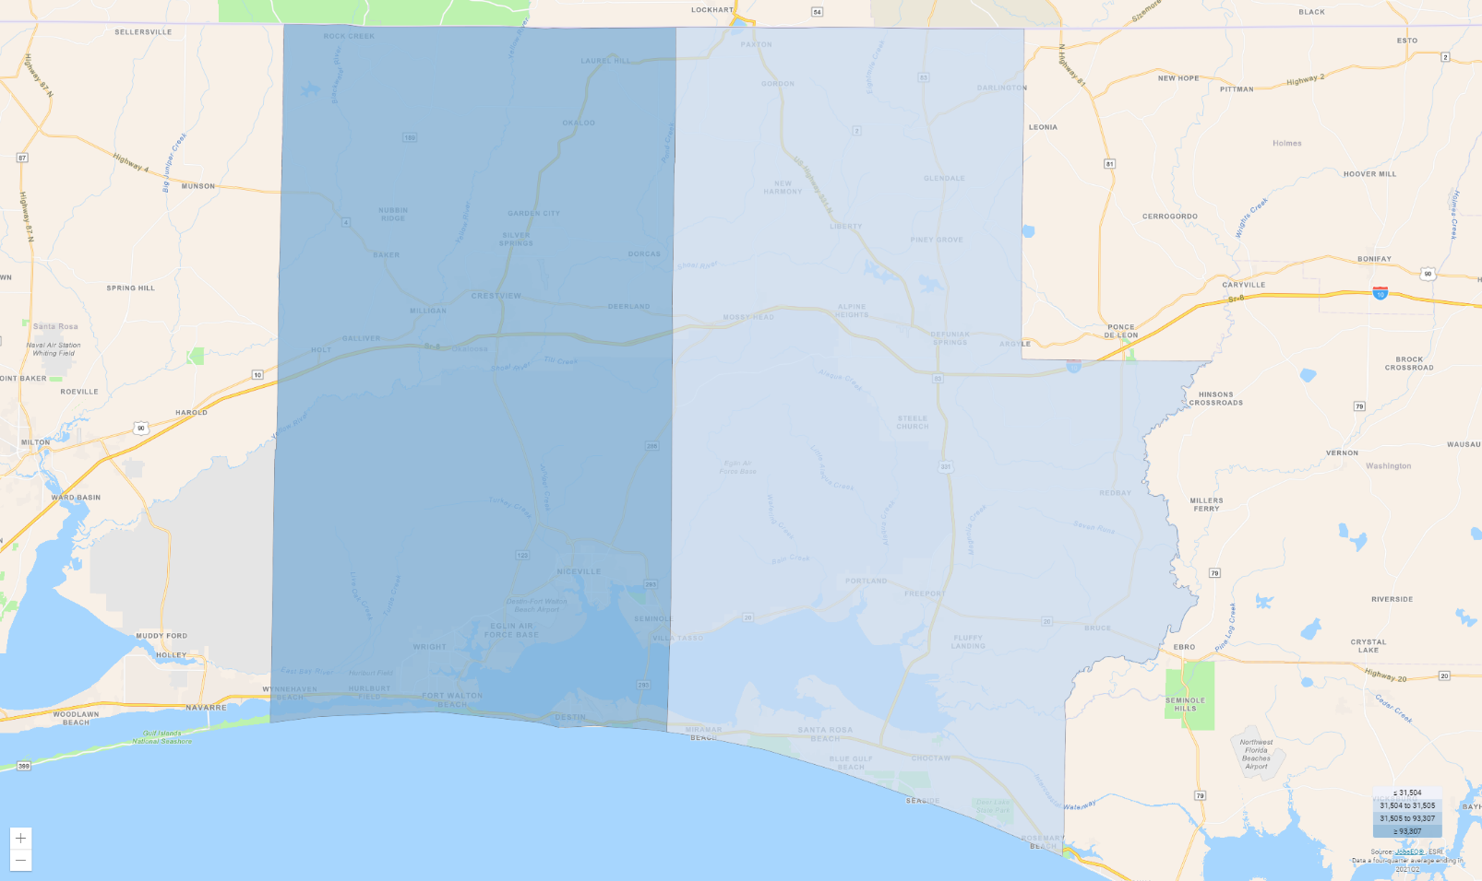

| **Region** | **Empl** |  | **Region** | **Empl** |
| --- | --- | --- | --- | --- |
| Okaloosa County, Florida | 93,308 |  | Walton County, Florida | 31,504 |

Source: [JobsEQ®](http://www.chmuraecon.com/jobseq)

|  |  |  |
| --- | --- | --- |
|  |  | A geographic concentration of firms in related fields of business may reduce production costs, attract more suppliers and customers, and increase supply and demand for specialized labor, but may also increase competitive pressure and drive down prices. |

# Drivers of Employment Growth

Over the ten years ending 2020, employment in Total - All Industries for the Okaloosa / Walton added 19,068 jobs. After adjusting for national growth during this period and industry mix share, the part of this employment change due to local competitiveness was a gain of 13,094 jobs—meaning this industry was more competitive than its national counterpart during this period.

cea_image_shiftShare

|  |  |  |
| --- | --- | --- |
|  |  | Shift-share analysis sheds light on the factors that drive regional employment growth in an industry. A positive change in local competitiveness indicates advantages that may be due to factors such as superior technology, management, and labor pool, etc. |
|  |  | National growth is due to the overall growth or contraction in the national economy. Industry mix share is the growth attributable to the specific industries examined (based on national industry growth patterns and the industry mix of the region). |

# Employment Distribution by Type

The table below shows the employment mix by ownership type for Total - All Industries for the Okaloosa / Walton. Four of these ownership types — federal, state, and local government and the private sector — together constitute “Covered Employment” (employment covered by the Unemployment Insurance programs of the United States and reported via the Quarterly Census of Employment and Wages).

“Self-Employment” refers to unincorporated self-employment and represents workers whose primary job is self-employment (that is, these data do not include workers whose primary job is a wage-and-salary position that is  
supplemented with self-employment).

cea_image_distribution

|  |  | **Empl** | **%** |
| --- | --- | --- | --- |
|  | Private | 93,009 | 74.5% |
|  | Self-Employment | 9,013 | 7.2% |
|  | Local Government | 9,140 | 7.3% |
|  | State Government | 1,942 | 1.6% |
|  | Federal Government | 9,263 | 7.4% |
|  | Other Non-Covered | 2,444 | 2.0% |

Source: [JobsEQ®](http://www.chmuraecon.com/jobseq)

|  |  |  |
| --- | --- | --- |
|  |  | Strong entrepreneurial activity is indicative of growing industries. Using self-employment as a proxy for entrepreneurs, a higher share of self-employed individuals within a regional industry points to future growth. |

# Establishments

In 2020, there were 9,976 Total - All Industries establishments in the Okaloosa / Walton (per covered employment establishment counts), an increase from 7,993 establishments ten years earlier in 2010.

cea_image_Est

|  |  |  |
| --- | --- | --- |
|  |  | New business formations are an important source of job creation in a regional economy, spurring innovation and competition, and driving productivity growth. Establishment data can provide an indicator of growth in businesses by counting each single location (such as a factory or a store) where business activity takes place, and with at least one employee. |

# GDP & Productivity

In 2020, Total - All Industries produced $16 billion in GDP for the Okaloosa / Walton.

cea_image_GDP

|  |  |  |
| --- | --- | --- |
| 100.0 %  Industry Share of Total GDP / **100.0 %** in the nation  cea_image_gdpShare | 4.3 % 🡹  Avg Ann % Change Last 10 Yrs / **3.4 %** in the nation  cea_image_gdpChange | $219k  Output per Worker / **$223k** in the nation  cea_image_productivity |

|  |  |  |
| --- | --- | --- |
|  |  | Gross domestic product (GDP) is the most comprehensive measure of regional economic activity, and an industry’s contribution to GDP is an important indicator of regional industry strength. It is a measure of total value-added to a regional economy in the form of labor income, proprietor’s income, and business profits, among others. |
|  |  | Growth in productivity (output per worker) leads to increases in wealth and higher average standards of living in a region. |

# Postsecondary Programs Linked to Total - All Industries

| **Program** | **Awards** |
| --- | --- |
| **Emerald Coast Technical College** | |
| Licensed Practical/Vocational Nurse Training | 35 |
| Phlebotomy Technician/Phlebotomist | 21 |
| **Northwest Florida State College** | |
| Business Administration, Management and Operations, Other | 35 |
| Child Care Provider/Assistant | 41 |
| Emergency Medical Technology/Technician (EMT Paramedic) | 37 |
| Registered Nursing/Registered Nurse | 100 |
| **Okaloosa Technical College** | |
| Automobile/Automotive Mechanics Technology/Technician | 36 |
| Computer/Computer Systems Technology/Technician | 31 |
| Heating, Ventilation, Air Conditioning and Refrigeration Engineering Technology/Technician | 23 |
| Licensed Practical/Vocational Nurse Training | 33 |

Source: [JobsEQ®](http://www.chmuraecon.com/jobseq)

|  |  |  |
| --- | --- | --- |
|  |  | The number of graduates from postsecondary programs in the region identifies the pipeline of future workers as well as the training capacity to support industry demand. |
|  |  | Among postsecondary programs at schools located in the Okaloosa / Walton, the sampling above identifies those most linked to occupations relevant to Total - All Industries. For a complete list see JobsEQ®, <http://www.chmuraecon.com/jobseq> |

# Okaloosa / Walton Regional Map

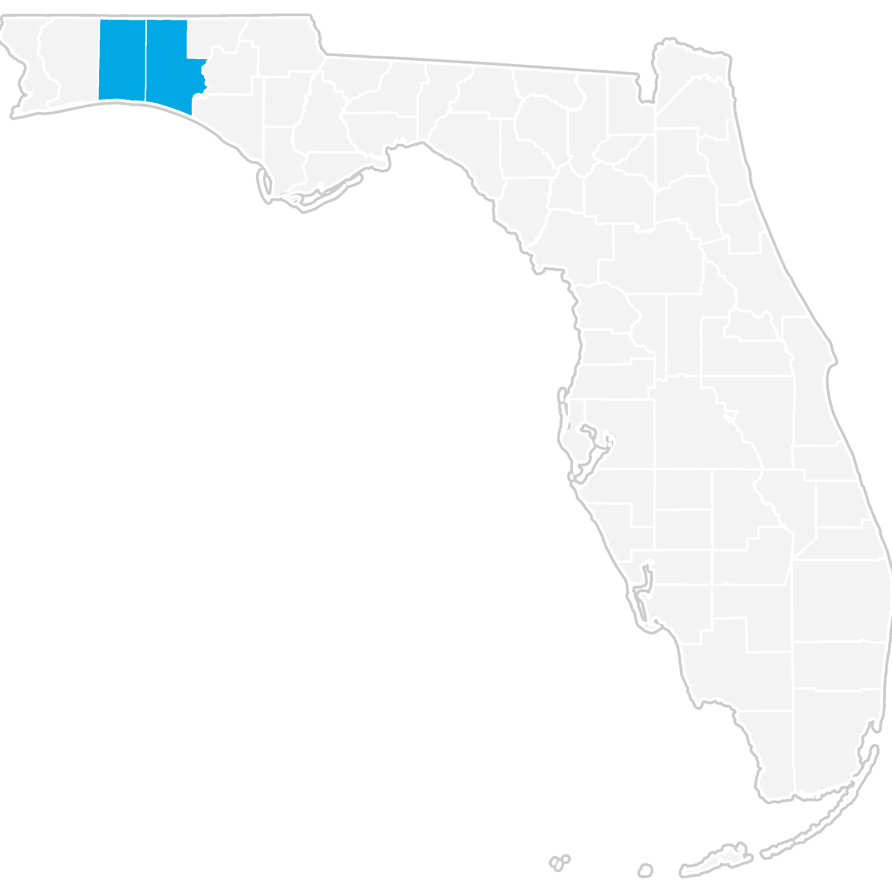

# Region Definition

| **Okaloosa / Walton is defined as the following counties:** | | |
| --- | --- | --- |
| Okaloosa County, Florida |  | Walton County, Florida |

# Data Notes

* Industry employment and wages (including total regional employment and wages) are as of 2021Q2 and are based upon BLS QCEW data, imputed by Chmura where necessary, and supplemented by additional sources including Census ZBP data. Employment forecasts are modeled by Chmura and are consistent with BLS national-level 10-year forecasts.
* Occupation employment is as of 2021Q2 and is based on industry employment and local staffing patterns calculated by Chmura and utilizing BLS OES data. Occupation wages are per the BLS OES data and are as of 2020.
* GDP is derived from BEA data and imputations by Chmura. Productivity (output per worker) is calculated by Chmura using industry employment and wages as well as GDP and BLS output data. Supply chain modeling including purchases by industry are developed by Chmura.
* Postsecondary awards are per the NCES and are for the 2019-2020 academic year.
* Establishment counts are per the BLS QCEW data.
* Figures may not sum due to rounding.

# FAQ

What is (LQ) location quotient?

Location quotient is a measurement of concentration in comparison to the nation. An LQ of 1.00 indicates a region has the same concentration of an industry (or occupation) as the nation. An LQ of 2.00 would mean the region has twice the expected employment compared to the nation and an LQ of 0.50 would mean the region has half the expected employment in comparison to the nation.

What is annual demand?

Annual demand is a of the sum of the annual projected growth demand and separation demand. Separation demand is the number of jobs required due to separations—labor force exits (including retirements) and turnover resulting from workers moving from one occupation into another. Note that separation demand does not include all turnover—it does not include when workers stay in the same occupation but switch employers. Growth demand is the increase or decrease of jobs expected due to expansion or contraction of the overall number of jobs.

What is the difference between industry wages and occupation wages?

Industry wages and occupation wages are estimated via separate data sets, often the time periods being reported do not align, and wages are defined slightly differently in the two systems (for example, certain bonuses are included in the industry wages but not the occupation wages). It is therefore common that estimates of the average industry wages and average occupation wages in a region do not match exactly.